Vegetable Soup
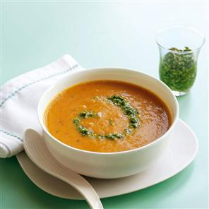
2 pints hot vegetable stock
1 onion
1 potato
2 parsnips
4 carrots
pepper
bay leaf

Chop all vegetables into similar sized chunks. Heat a little butter & a drop of oil in a large pan and gently sweat the onions until just soft. Add all the other vegetables and sweat for 5 mins with the lid on. Add the hot stock and bay leaf, bring to the boil then reduce heat and simmer with the lid on for 20 mins until the vegetables are cooked. Remove from the heat and allow to cool before removing bay leaf and blending to make a smooth soup. Season to taste.

Muffin Pizza

These are a firm favourite and are so quick & easy to make !

Take half a muffin, spread with tomato ketchup and top with grated cheese and a sprinkle of mixed herbs – bake for 8 - 10 mins in hot oven. We serve these with homemade wedges & baked beans.

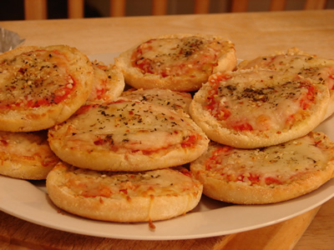

Fish Pie

600g Fish – we use cod, but you can use any fish – un-dyed smoked Haddock makes a nice addition, and it’s a good way to introduce oily fish such as fresh Mackerel and Salmon.
White sauce:
1½ tbs cornflour
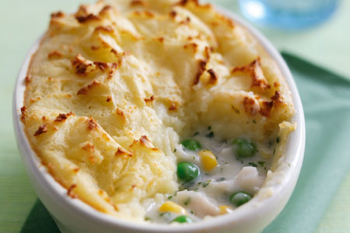
1 pint of Milk
knob of Butter
Pepper
Handful grated cheese
Frozen Mixed vegetables
Potatoes

Poach fish in milk or vegetable stock for 20 mins, then flake & check for bones. Meanwhile boil the potatoes and when cooked, mash with a little butter and milk.
To make the sauce, melt the butter in a pan, stir in the cornflour to make a paste, then slowly add the milk, stirring all the time to make a smooth sauce. Bring to the boil and simmer until thickened – keep stirring ! Add pepper and cheese to taste (or mustard if you prefer!)
Mix the frozen mixed vegetables, fish and sauce together in an ovenproof dish, top with mashed potato and bake in a preheated oven (200⁰) for 30 mins until golden brown.

Oat Chocolate Chip Cookies
(makes 18) Pre-heat oven to 180º C.

- oz Oats
9oz plain flour
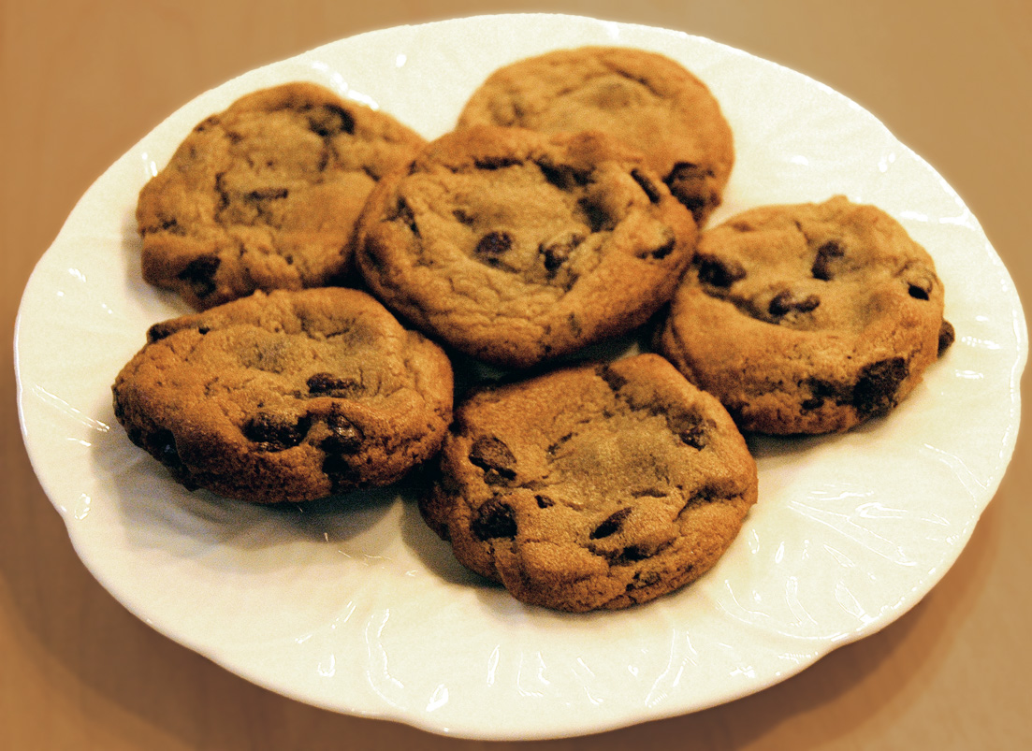
- oz sugar
6 oz Stork Margarine
1 tbs golden syrup
¾ oz baking powder
- oz chocolate chips

Melt the margarine & syrup in a pan (or microwave), add dry ingredients (except chocolate chips) and mix well. Add the chocolate chips and fold in gently. Roll a teaspoon of the mixture into a ball and flatten gently onto a lined baking tray. Bake for approx 10 mins, remove from oven while still soft as they will firm up when cool.

Banana Loaf
2 ripe bananas
6oz margarine
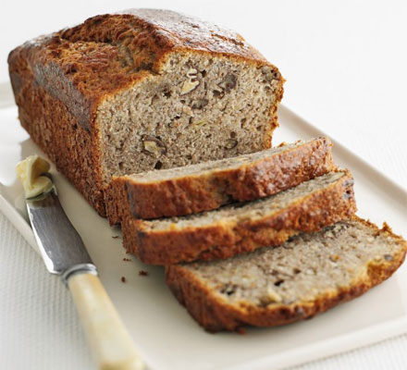
6oz caster sugar
2 eggs
8oz self raising flour
½ tsp baking powder
½ tsp vanilla essence
½ tsp ground cinnamon

Pre-heat oven to 180ºc, grease & line a 1ib loaf tin.
Peel & mash bananas. Beat together the margarine and sugar then add the eggs, flour & baking powder. Mix well then add the bananas and fold in with the vanilla and cinnamon. Pour mix into tin and bake for about 40 mins. Cool slightly then turn out to completely cool before trying to slice.

