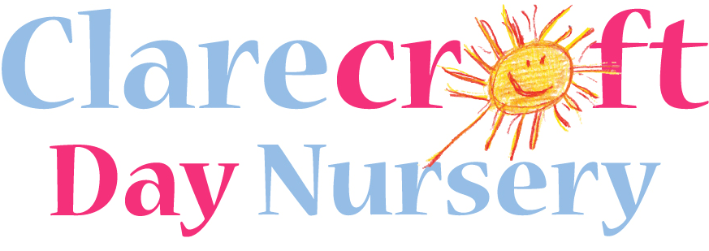
34 High Street, Long Buckby, Northampton NN6 7RD
01327 844 474 admin@clarecroft.co.uk

Dear Parents and Carers,

Although some of you may have heard us refer to ‘Heuristic Play’, many of you may not be aware of how this simple, but effective method of encouraging child development works so I’d like to offer you this introduction and also ask for your help in developing our Heuristic Play resources.

Over 30 years ago an Educational Psychologist called Elinor Goldschmeid studied how children gained knowledge of the world around them, from these studies the concept of Heuristic Play was developed. Heuristic play actively encourages a child’s natural instincts to explore by using and developing their senses. As we know, children investigate objects around them and make discoveries through taste, touch, smell, sound and sight.

During Heuristic Play sessions children explore different materials and objects without adult direction or interaction - the role of the adult is to support the children by collecting objects, setting out the activity and observing the children’s reactions.

Objects used in Heuristic play are simple everyday and natural items. They provide opportunities to: fill /empty, slot together, build /balance, select/ disregard
and recognise differences / similarities

Through these activities even very young children have the opportunity to develop their imagination , manipulative skills, problem solving, sequencing, anticipating and rearranging objects. Children will also develop their concentration skills by using these materials. There is no right or wrong way for the children to explore the objects.

Our Baby Room provide sessions of Heuristic Play and already we are beginning to see the benefits of these opportunities and the delight in the children's faces as they make new discoveries.

Where you can help !
Heuristic Play needs constant replenishment with new and exciting objects to explore. These items are stored in ‘Treasure Baskets ‘ and they are regularly changed to provide new stimulus. To do this we need to collect a variety of objects.

Items for Treasure Baskets.

The following items are ideal for supporting Heuristic Play. If you would like to donate any objects please bring them to The Baby Room - any objects that you are not sure of can be risk assessed by staff, so please do bring them in !

Natural Objects  Fir cones  Pebbles  Shells  Feathers  Corks  Pumice stone  Loofah  Conkers  Natural sponge  Avocado pear stones | Wooden Objects  Clothes pegs  Curtain rings  Wooden nail brush  Wooden egg cup  Spoons  Wooden bowl  Honey dipper  Pastry brush  Shaving brush  Small baskets  Paint brush  Rolling pin  Cotton reels  Wood off-cuts | Metal Objects  Length of metal chain  Spoons  Tin lids  Garlic crusher  Metal beaker  Brass curtain rings  Bunch of keys  Metal bowl  Tea strainer  Whisk  Empty tins  Bells
Leather, textile,  rubber or fur objects  Coloured ribbons  Velvet powder puff  Piece of leather  Flannel  Woollen ball  Leather purse  Rubber gloves  Small soft toy  Small flannel  Rubber ball  Tennis ball  Fur fabric  Small raffia  Leather glasses case | Paper / Cardboard  Objects  Notebook  Greaseproof paper  Egg boxes  Sturdy cardboard tubes  The circles from inside  sticky tape | Other Objects  Small jar and lid  Plug and chain  Hair rollers  Toothbrush  Scent bags  Shoe horn  Ceramic bowl  Anything that will take a child’s interest!

Thank you for your continuing support.

Tina Johri

